

University of Piraeus

Department of Digital Systems

Course: Environmental and Climate Change Systems and Policies

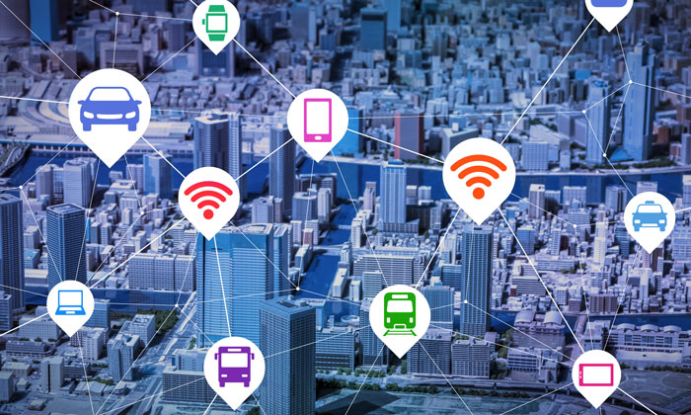

**Konstantinos Chikimtzis**

SUpervisor: prof. Yannis maniatis

Digital Systems Solutions for Traffic Congestion

Piraeus, 2020

The Problem 2

**Climate Crisis** 3

**Greenhouse Gasses** 4

**The Urbanization Problem** 6

**Urban Mobility** 10

**Congestion** 11

**Air Pollution & CO2** 12

**Overall** 13

The Goal 15

Urban Mobility Solution: Smart Traffic 17

# The Problem

### **Climate Crisis**

In October 2019, more than **11,000** Scientists around the world declare ‘Climate Emergency’.

This is the first time a large group of scientists have jointly used the word "emergency" when talking about climate change. “Climate change has arrived and is **accelerating** faster than many scientists expected.”

The current **global average temperature is 0.85ºC higher** than it was in the late 19th century. Each of the past three decades has been warmer than any preceding decade since records began in 1850.

In **Europe** temperatures have repeatedly broken long-term records in recent years. Some observed and projected climate change impacts for the Mediterranean region in Europe are:

* Large increase in heat extremes
* Increase in mortality from heat waves
* Decrease in summer tourism and potential increase in other seasons
* Increase in multiple climatic hazards
* Most economic sectors negatively affected

***Source:*** *EEA, 2017, Climate change, impacts and vulnerability in Europe 2016 – An indicator-based report, EEA Report No. 1/2017.*

***Source****:* [*Knowledge for a sustainable Europe*](https://www.eea.europa.eu/publications/eea-snapshot)

### **Greenhouse Gasses**

Our planet is experiencing significant and accelerated climate change **caused by greenhouse gases** emitted by human activities.

The effects are being felt on all continents and are predicted to become more and more intense, with severe consequences for our economies and societies.

**What Are Greenhouse Gasses?**

Some gases in the Earth's atmosphere act a bit like the glass in a greenhouse, trapping the sun's heat and stopping it from leaking back into space.

Many of these gases occur naturally, but human activity is increasing the concentrations of some of them in the atmosphere, in particular:

* carbon dioxide (CO2)
* methane
* nitrous oxide
* fluorinated gases

**CO2** is the greenhouse gas most commonly produced by human activities and it is **responsible for 64% of man-made global warming**. Its concentration in the atmosphere is currently 40% higher than it was when industrialization began.

One of the main causes for the rising emissions is the **burning of coal, oil and gas** as it produces carbon dioxide and nitrous oxide.

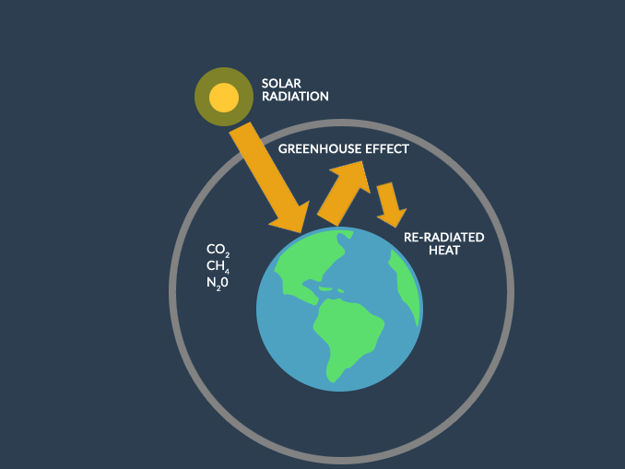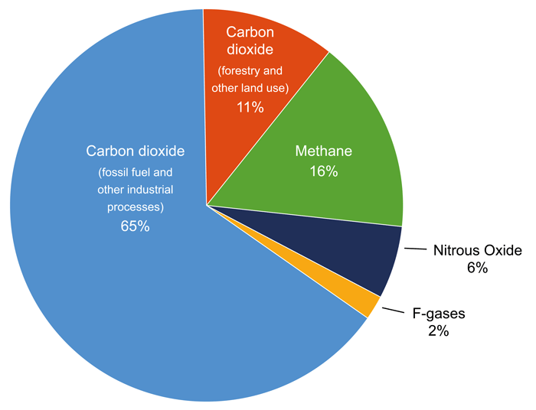

***Source****: Contribution of Working Group III to the Fifth Assessment Report of the Intergovernmental Panel on Climate Change*.

### **The Urbanization Problem**

**International**

**Cities are major contributors to greenhouse gas emissions**. Half of the world’s population lives in cities, a share that is likely to reach 70 percent in 2050. Cities consume as much as 80 percent of energy production worldwide and account for a roughly equal share of global greenhouse gas emissions.

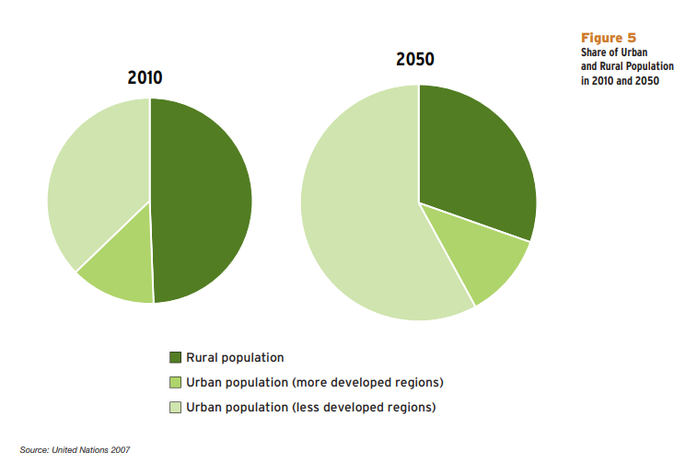

***Source****:* [*United Nations 2007*](https://www.un.org/en/development/desa/population/publications/pdf/urbanization/2007_urban_rural_chart.pdf)

The International Energy Agency (IEA) estimates that urban areas currently account for over 67 percent of energy-related global greenhouse gases, which is expected to rise to 74 percent by 2030. It is estimated that 89 percent of the increase in CO2 from energy use will be from developing countries (IEA 2008).

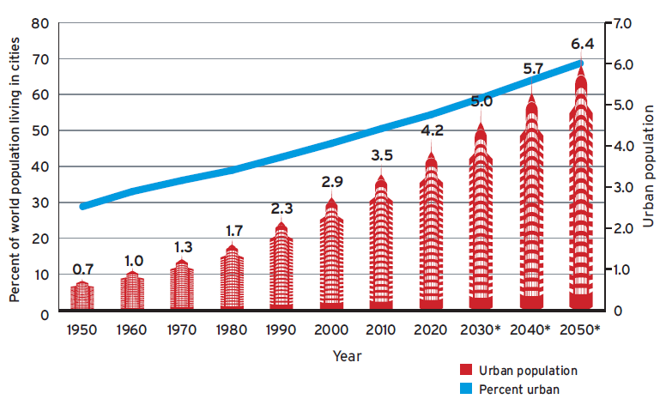**Urban population is expected to double by 2030, however the global built-up area is expected to triple during the same period**. This building out instead of building up will dramatically increase energy requirements and costs of new infrastructure. Poorly managed cities exacerbate enormous new demands for energy and infrastructure investment.

***Source****: UN, Department of Economic & Social Affairs, Population Division.*

**Europe**

In 2010, 73% of European citizens lived in urban areas. It is expected

that this percentage will increase to over **80% by 2050**. In some

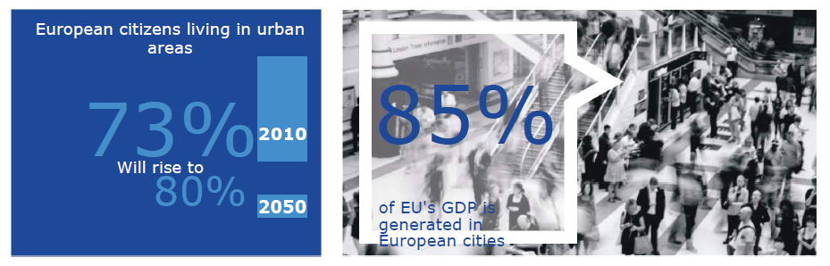countries like Sweden, Belgium, the Netherlands, Denmark, Malta and Luxembourg the urbanization rate will rise to over 90%.

***Source****:* [*European Urban Mobility - Policy Context*](https://civitas.eu/document/european-urban-mobility-policy-context)

On average, the European network of cities **is denser than in other parts of the world**, with predominantly mid-sized rather than large cities. European cities, with a density of 3 000 residents per km2, are almost twice as dense as North American ones, but less dense than those in Africa and Asia. The majority of Europeans are concentrated in cities with populations between 250 000 and 5 million.

**JRC projections to 2030 show that most European regions hosting major cities are expected to experience urban population growth** *(Figure 7, top)*. Indeed, some regions will see significant growth in their urban population (greater than 35%, and up to almost 60% in Stockholm), particularly in southern France, northern Italy and southern Germany. However, population decline is foreseen in core cities in Spain (Madrid, Barcelona and Valencia), Portugal (Porto), and Lithuania (Vilnius), and in clusters of regions throughout most of Eastern Europe, Germany, and the Iberian Peninsula (35% and above).

***Source:*** [*The Future of Cities*](https://ec.europa.eu/jrc/en/publication/eur-scientific-and-technical-research-reports/future-cities)

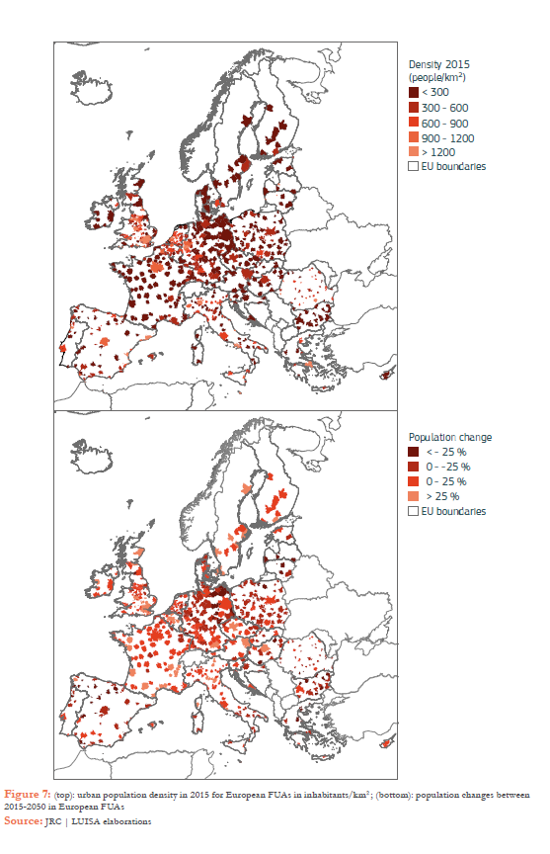

### **Urban Mobility**

Transport remains one of the biggest challenges for decarbonizing the economy and with urbanization increasing, problems occur.

Urban transport systems are **vital** to the economic functioning of

cities through their provision of accessibility for goods and

commuters. Similarly, they are vital to the welfare of the population

by providing accessibility for all social activities.

However, due to the extensive economic activity in urban areas, many European cities face several problems related to or caused by **transport and traffic**. Economic and social transformation has rapidly increased the levels of mobility. **The growth of private car use has been accompanied by increased urban sprawl and commuting**, whereas the expansion of public transport networks in many cases has not been developed at the same rate.

At the same time transport systems can generate negative

external effects.

**Congestion, air and noise pollution** are examples of commonly shared problems in European cities. Besides this direct

impact, urban transport also affects social development, social inclusion and accessibility for people with reduced mobility. European cities face the challenge of how **to enhance mobility, ensure accessibility**, and create high quality and efficient transport systems while at the same time **reducing congestion, pollution and accidents.**

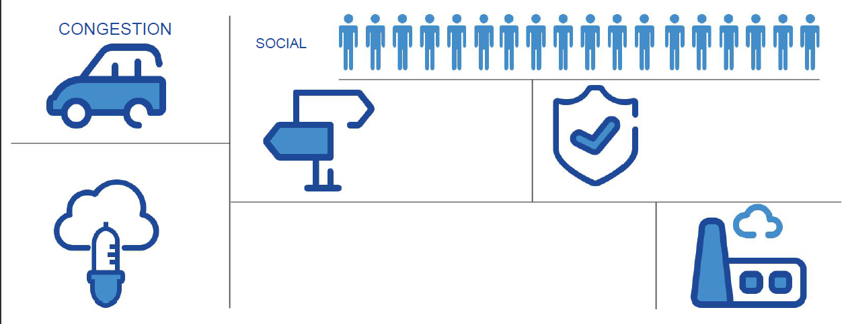

### **Congestion**

Congestion in urban environments is a complex phenomenon with

many dimensions: demographic, social and economic characteristics,

land use patterns, car-ownership, availability of public transport,

availability of parking, and urban freight transport and goods

delivery. These are all factors that influence the level of congestion and they are **important to understand** so we can think of solutions.

These factors shape activity patterns, which in turn generate a demand for travel. This demand for travel results in

traffic on the urban road network. **When the volume of car traffic**

**exceeds available capacity, congestion arises**.

The average percentage delay in 2013 in percentages compared to

the "free flow” situation in a sample of 58 EU cities ranges from **14%**

**in Malmö** (Sweden) to **39% in Palermo** (Italy). During peak hours the

delays are substantially higher.

The cost of congestion in Europe is still high, estimated at around

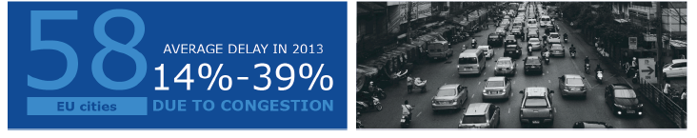EUR **130 billion annually**, or just over one percent of the EU's GDP.

Congestion does not only damage the economy, but it damages people’s health too.

***Source****:* [*European Urban Mobility - Policy Context*](https://civitas.eu/document/european-urban-mobility-policy-context)

### **Air Pollution & CO2**

Congestion leads to air pollution. **The main factors** determining air pollution caused by road traffic are:

**Volume of traffic Speed / congestion Propulsion types**.

Transport also contributed to **13%** and **15%** of total PM10 and PM2.5 primary emissions, respectively, in the EU‑28 in 2014. (Source EEA Air Quality in Europe Report 2016).

In fact, around **85 % of city dwellers in Europe are exposed to fine particulate matter** (PM2.5), which is estimated to reduce average life expectancy in the EU by more than **8 months**.

***Source:*** [*Knowledge for a sustainable Europe*](https://www.eea.europa.eu/publications/eea-snapshot)

**CO2 emissions** from road freight transport were **33% higher** in 2012

than in 1990 and made up 35% of total transport emissions.

### **Overall**

Urbanization



Urban Mobility Problems

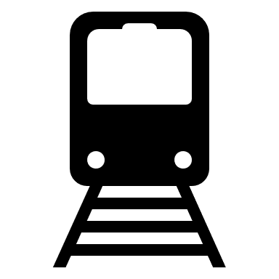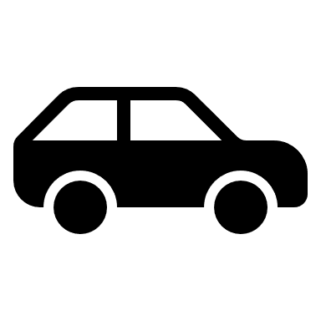



Congestion

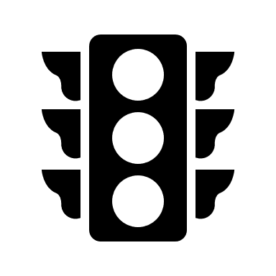

Greenhouse Gasses



The world's leading climate scientists think **human activities like urban mobility are almost certainly the main cause of the warming** observed since the middle of the 20th century.

With urbanization and the use of the private car increasing, traffic congestion is nowadays one of the biggest problems Europe faces and actions are already being taken.

Clean air is essential for our health, our environment and our economy. Our planet is experiencing significant and accelerated climate change caused by greenhouse gases emitted by human activities.

The scale of financial resources needed to effect sustainability transitions is daunting. The costs of inaction may be even greater. It is estimated that EUR 1 Trillion worth of investments is needed,

annually, from 2021 onwards, to meet the EU's 2030 climate and energy targets.

# The Goal



The effects of climate change are being felt on all continents and are predicted to become more and more intense, with severe consequences for our economies and societies.

To stop climate change from getting worse, we must take action to **cut greenhouse gas emissions significantly** and adapt to the changes happening now and, in the future, to limit the damage.

The Paris Agreement sets out a global framework to avoid dangerous climate change by limiting global warming to well **below 2°C** and pursuing efforts to **limit it to 1.5°C**. It also aims to strengthen countries’ ability to deal with the impacts of climate change and support them in their efforts.

The overall aim is to reduce greenhouse gas emissions, air pollution and noise levels **as well as congestion**. As a result, there will be big savings in health costs and pollution control measures.

* For 2030, the EU has set targets to achieve a **40%** reduction in greenhouse gas emissions.
* Also, the EU is aiming for a [**60% cut in transport emissions**](http://ec.europa.eu/transport/themes/strategies/2011_white_paper_en.htm) by 2050 compared to 1990.

The core elements of the strategy to achieve this are:

* **Increasing the efficiency of the transport system**by making the most of digital technologies, smart pricing and further encouraging the shift to lower emission transport modes.
* **Speeding up the deployment of low-emission alternative energy for transport,**such as electricity.
* **Moving towards zero-emission vehicles.**

***Source****:* [*A European Strategy for low-emission mobility*](https://ec.europa.eu/clima/policies/transport_en)

We are going to focus mainly on the first element of the strategy: **Making the most of digital technologies to increase the efficiency of the transport systems** **and fight congestion** in European cities. Improving congestion will certainly cut down transport emissions and make our commutes more pleasant.

# Smart Traffic Management

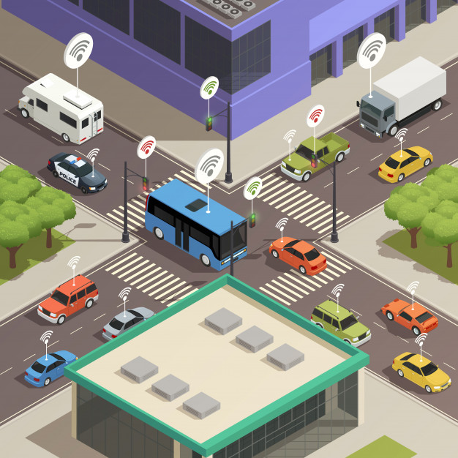

A very sustainable urban mobility solution is smart traffic management. The implementations of smart traffic solutions vary from city to city, so we need to first understand the fundamental concepts of these solutions.

### **What is Smart Traffic Management?**

Smart traffic management incorporates a range of technologies and a myriad of data sources to control or support control of **traffic based on real-time traffic congestion levels** and other conditions.

Some intelligent traffic management systems integrate with transit data incorporating scheduleand on-time performance data of scheduled bus and rail routes. In addition, intelligent traffic management helps build a rich database of mobility information, which can contribute to further traffic and mobility improvements.

Some **elements** of smart traffic management include:

1. Signalling that adapts automatically to congestion and road traffic conditions.
2. Collecting vehicle movement data throughout the city
3. Integrating with transit data.
4. Analysis of roadway and intersection performance.
5. Sensing pedestrians and bicycles and integrating this data.
6. Integration with emergency vehicles.

With smart traffic control, a smart intersection automatically adapts to real-time congestion and roadway conditions. A typical traffic signal cycle is fixed in duration, while a smart intersection has flexible, adaptive signal cycles. A system of **smart intersections can identify and calculate the queue of cars at an intersection and at other intersections to eliminate congestion**. For example, after a sporting event or a concert, traffic can be cleared faster than the normal signal timing would allow.

### **How Smart Traffic Management Works**

We can split the smart traffic management system infrastructure in 3 layers:

* Data Acquisition and Collection Layer.
* Data Computation and Processing Layer.
* 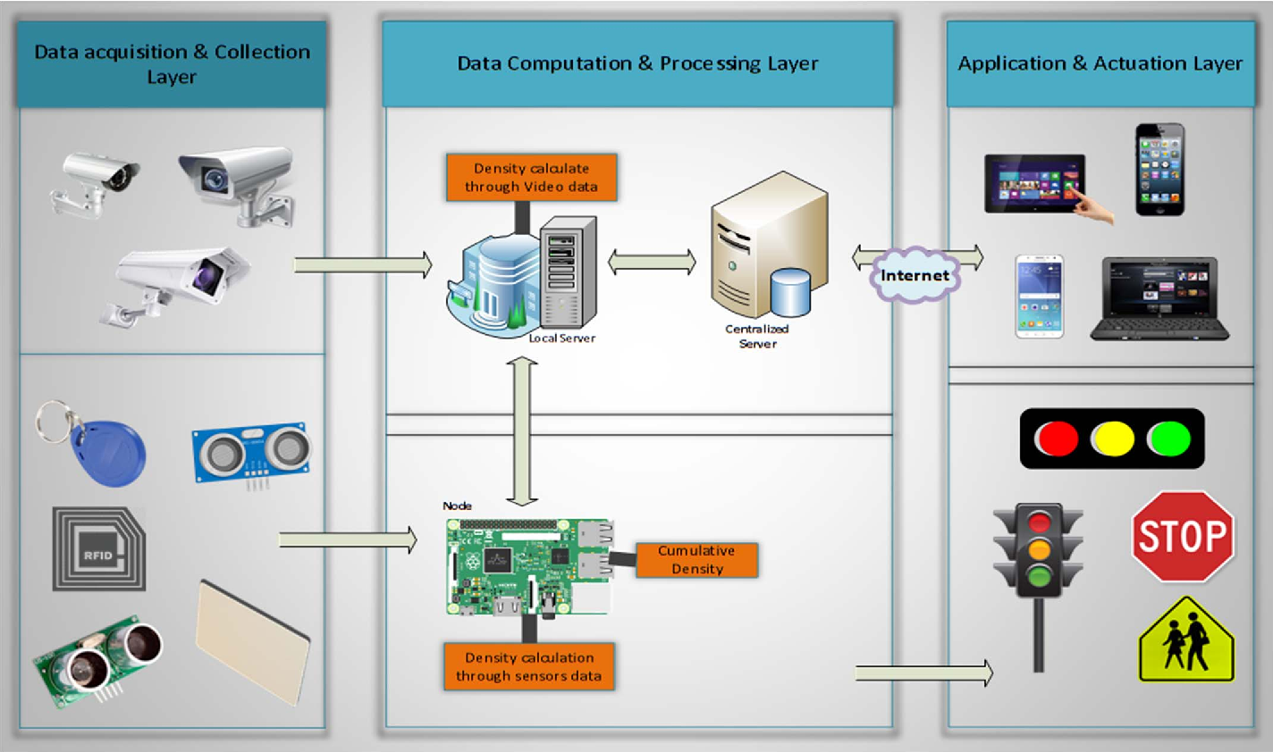Application and Actuation Layer.

***Source:*** [*Smart traffic management system using Internet of Things*](https://www.semanticscholar.org/paper/Smart-traffic-management-system-using-Internet-of-Javaid-Sufian/ccafb1bca5c2a47211870b11af2e24e348f05563)

* **Data Acquisition and Collection Layer**

Smart traffic management incorporates intelligence- and communications-enabled roadways and intersections with data collected from **sensors**, **cameras**, **vehicles**, **GPS**, **mobile** **devices**, **transit timetables**, and other sources.

* **Data Computation and Processing Layer**

Computations and analytics can be performed in the **Cloud** or **at the Edge**, depending on the need and requirements for **speed** and **scalability**.

For **safety-critical functions**, **communications** **must be super-low latency**. Dedicated short-range communication (DSRC) is one communications platform, while 5G is currently in development as a more ubiquitous solution.

For **non-safety-sensitive** transmissions and for activities like monitoring the signal network or performing remote maintenance, **slower communications platforms may be acceptable** and, in general, the traffic signal controllers must be connected to the internet.

* **Application and Actuation Layer**

A systems approach analyzes data across geographies and modes. For example, if traffic is congested in an area five miles away from a driver near his/her destination, **the system will know not to advise the driver to use a road through that area**. Meanwhile**, traffic signals will change based on the length of traffic queues** at the signal and in the surrounding area.

Besides this, **RFIDs** will also be used to **prioritize the emergency vehicles** like ambulance, fire brigade etc. by implementing RFID tags in such vehicles. In the case of emergency situations, such as fire explosion or burning of something, fire and smoke sensors are also deployed on the road to detect such situations.

### **Smart Traffic Lights**

**How can they help?**

Smart management of traffic signal lights can reduce congestion and make traffic flow more smoothly in cities by using a **signal priority system**. This system gives certain vehicles a green light faster than others, reducing their travel time.

Smoother traffic rhythm reduces stops and queuing, which in turn **reduces emissions**, consumption and noise.

**How this signal priority system is made?**

These systems are empowered by **AI**. AI-enable traffic lights use **machine vision to adjust to the flow of traffic**, minimizing the driving time. These traffic signals can adjust in real time to optimize traffic patterns and increase the movement of traffic.

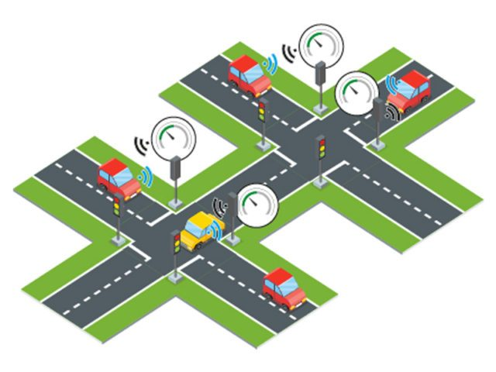Carpool lanes can be changed in real time, if needed, with **priority given to buses and rideshare vans to speed up commutes**. The public transit experience can be improved as well, with applications that keep riders informed with real-time schedules and delays so users can determine when they need to leave to catch a train in time and avoid long waiting periods.